|  |
| --- |
| **JDN Standards - RDM** |

1 Deploy Template 2

2 Change Entry’s 3

2.1 Vessel / Office Name 3

2.2 Clients 4

2.3 Firewall & Switch 5

2.4 Synology NAS 6

2.5 Servers 6

2.6 Time Server 6

2.7 UPS 6

2.8 Users 7

2.9 WLAN 7

# Deploy Template

Deploy the “Template – New Standard” to the correct location.

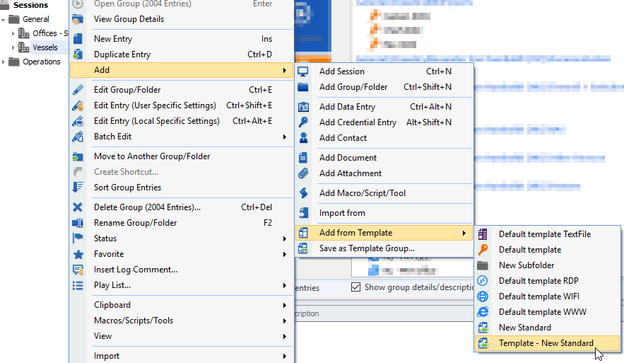

# Change Entry’s

## Vessel / Office Name

Change the name to “vessel/office (XX) – New Standard”

Right click on the folder “New Standard” > Properties

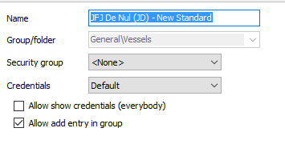

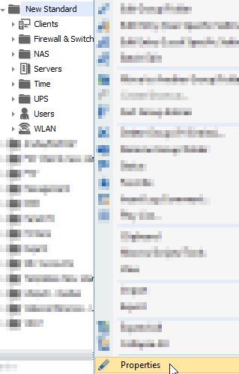

## Clients

For all clients change the XX by the vessel abbreviation.

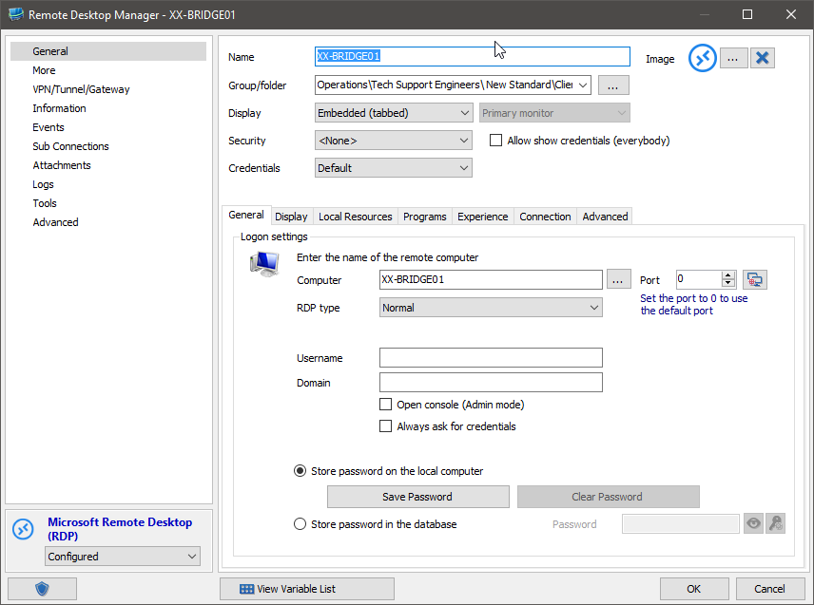

If there are additional clients, add them.

## Firewall & Switch

* Change for all objects the XX to the vessel abbreviation.
* For the IP-address change the XX with the admin-trust range.
* Add the **Password**.

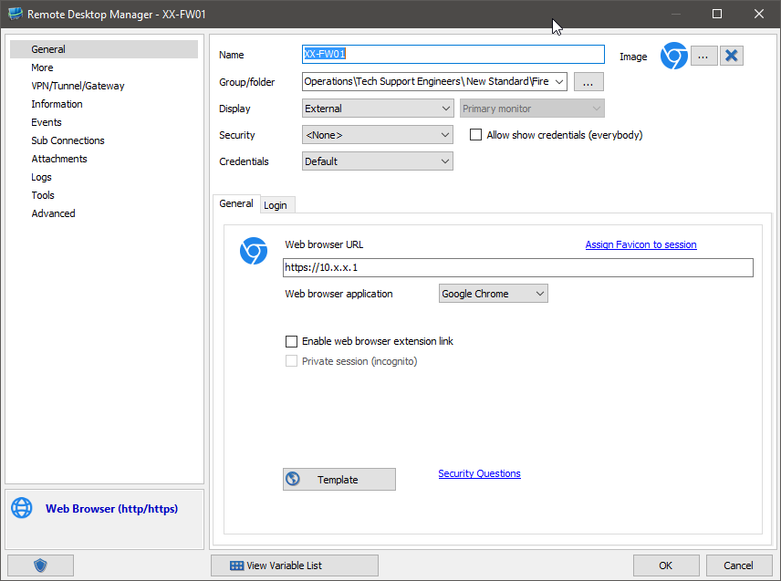

For additional switches add SSH and URL-object

## Synology NAS

* Change for all objects the XX to the vessel abbreviation.
* For the IP-address change the XX with the admin-trust range.
* For the IP-address of the Machine-NAS change the XX with the Machine range
* Add the **Password**.
* Add the MAC-address of LAN 4 (Admin-trust) at the “Information” tab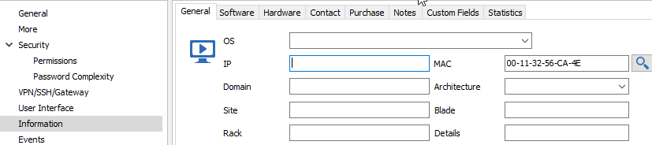

If there is no Machine NAS-cluster, delete them.

## Servers

* Change for all objects the XX to the vessel abbreviation.
* For the IP-address change the XX with the admin-trust range.
* Add the **Password**.
* Add the TeamViewer ID to the properties of XX-MGMT01

Delete the objects you don’t use.

## Time Server

* Change the XX to the vessel abbreviation.
* Do NOT change the IP-address.
* Add the **Password**.

## UPS

* Change the XX to the vessel abbreviation.
* For the IP-address change the XX with the admin-trust range.
* Add the **Password**.

## Users

* Change for all objects the XX to the vessel abbreviation.
* Add the **Password**.

DO NOT CHANGE THE PASSWORD FOR **AMOS** AND **TD**. We use generic credentials on all vessels. If needed reset the password.

Add additional accounts.

## WLAN

* Change for all objects the XX to the vessel abbreviation.
* Add the **Password**.
* Change the description of the XX-WLAN01 object with the ports that reserved for ARUBA TRUNK.